**MIRACLE SAINTS JUNIOR SCHOOL NKUMBA**

**MID TERM II ASSESSMENT 2024**

**TOP CLASS: (5 – 6 YEARS)**

**LEARNING AREA 3: HEALTH HABITS**

**My name is: ………………………………..………………………….**

**My School is: ……………………………..……….…………………..**

**I am in: ………………………………..…………………………………………..**

1. **My school is _________________________________**
2. **I have __________legs.**
3. **I have __________ head.**
4. **________ days make a week.**
5. 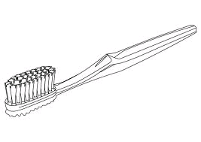 **This is a _________________.**

**(toothbrush, comb)**

**We use it for _______________________.**

**(brushing, combing)**

1. 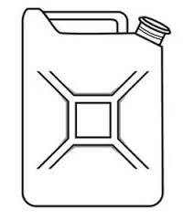**Name these things found at home**

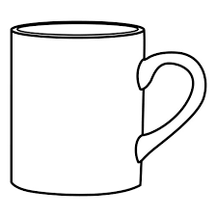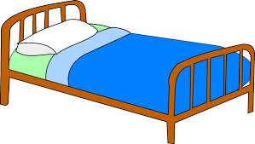

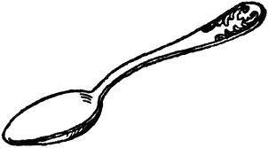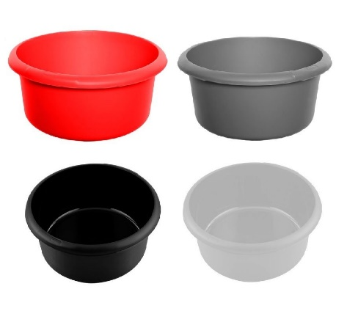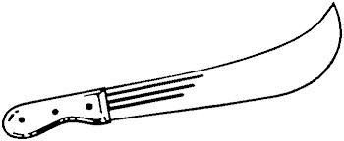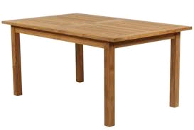

1. 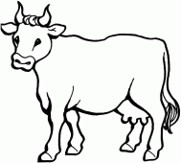**Circle the wild animals only.**

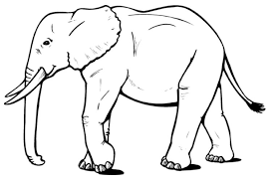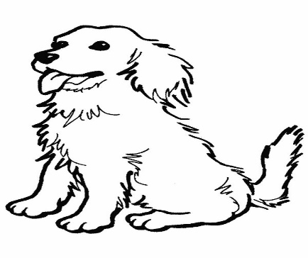

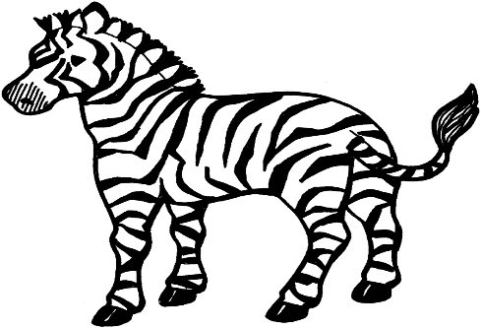

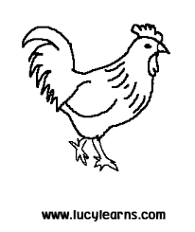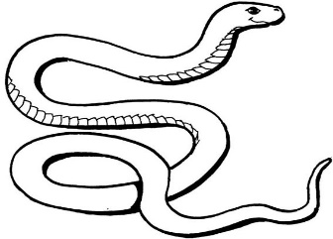

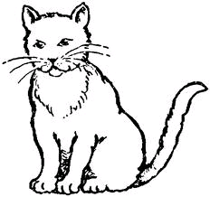

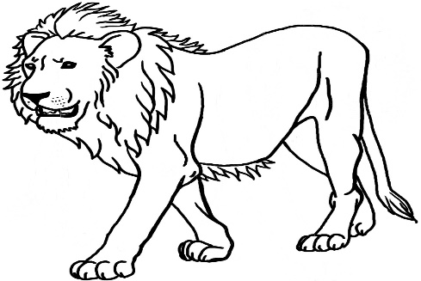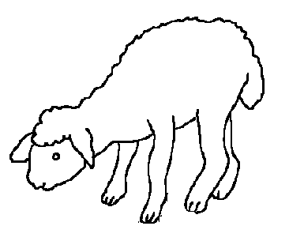

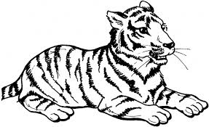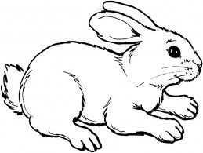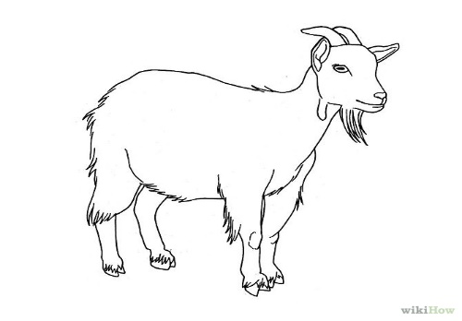

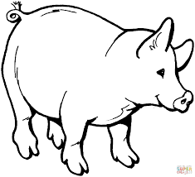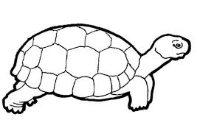

1. **Match the same words and write.**

ear pad towel ___________

water basin ___________

sponge ear pad___________

soap sponge ___________

towel water ___________

basin soap ___________

1. 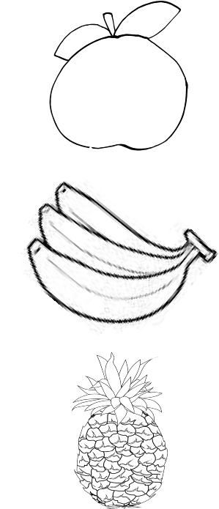**Name these fruits.**

________________

_______________

_________________

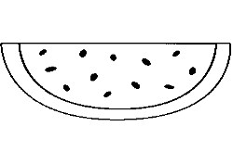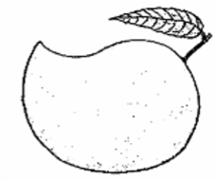

______________

_______________

(watermelon, mango, pineapple, apple, banana)

**END**